OAGC VIRTUAL Family & Community Day  SUNDAY October 16, 2022  2:00 p.m. to 5:00 p.m.  Featuring Keynote Presenter  Jonathan Plucker  Jonathan Plucker is the Julian C. Stanley Endowed Professor of Talent Development at Johns Hopkins University, where he works in the Center for Talented Youth and School of Education. He graduated with a B.S. in chemistry education and M.A. in educational psychology from the University of Connecticut, and a Ph.D. in educational psychology from the University of Virginia. His research examines education policy, creativity, and talent development, with over 300 publications to his credit. Recent books include Excellence Gaps in Education with Scott Peters and Creativity and Innovation. He is a recipient of the 2012 Arnheim Award for Outstanding Achievement in the Psychology of Creativity from APA and 2013 Distinguished Scholar Award from the National Association for Gifted Children. He is a past-president of the Society for the Psychology of Aesthetics, Creativity, and the Arts and immediate past-president of the National Association for Gifted Children.  Family and Community Panel  Alyssa Louagie – Lakota LEADS President  Maggie Gunnerson – GEAR President  Lauren Webb – Lakota City Schools  Stefanie Hall  Stefanie Hall is the gifted coordinator for the South-Western City School District.  Joseph Januzzi, NCSP  School Psychologist Panel  Co-presenters:  Joseph Januzzi, NCSP  School Psychologist  jjanuzzi@scs-k12.net  Sarah Kaya, LSW  School Social Worker  skaya@scs-k12.net  Morgan Dunleavy, MSW, LSW  School Social Worker  mdunleavy@scs-k12.net  For questions of for more information please  contact Sara Watson at  watson.sara@gmail.com or visit www.oagc.com/fallconference.asp |  |  |  | 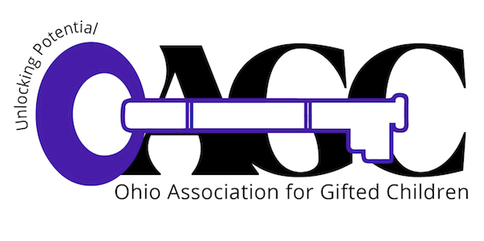REGISTRATION FREE!  2:00–2:10 PM Welcome  2:10–3:00 PM Keynote by Jonathan Plucker  3:00—4:10PM How Parent Involvement Increases Advocacy  4:10–5:00 PM Third Session – Helping Children Dealing with Grief: Bringing Hope  “Encouraging Creativity” - Jonathan Plucker  Creativity is a highly valued 21st century skill, but what do we know about how to develop it in children? Is it the same in both children and adults? What does the latest research tell us about how to help create cultures of creativity? How can we even define it? We will explore these and other questions, with an emphasis on understanding the nature of creativity and how it manifests itself in the lives of our children, both in and outside of school.  “How Parent Involvement Increases Advocacy”  This session will feature two parent advocate groups: GEAR with Sycamore Schools and LEADS from Lakota Schools with facilitation of the session by Lauren Webb, Lakota Local Schools Assistant Director. Both parent groups will offer how they provide support and enrichment opportunities for families and how their involvement has increased advocacy within their districts. The session will focus on the origins, benefits, and challenges of the two parent advocacy groups as a way to encourage more families to advocate and start a support system locally. Each attendee will leave with an understanding of how school districts can partner with families to increase outcomes for their students. Time will also be allotted for q and a with participants.  “Helping Children Dealing with Grief: Bringing Hope”  Conflicting feelings are normal and natural after a loss (death, divorce, pet loss, moving, or any other loss) and can increase with overexcitabilities. We have been socialized to believe that these feelings are abnormal and unnatural. We will review the myths surrounding grief and identify tools to help children.

OAGC Family & Community Day
Registration Form
FREE!!!

Complete and return this registration form to the address below by October 10, 2022 or fill out the google form. After October 10th, registrations will be accepted via email and fax or by google form.

Name:

Street address:

City, State, ZIP:

County: | Phone:
E-mail:

Please return your completed registration form by October 10 to
Parent Day Registration
Ohio Association for Gifted Children
P.O. Box 30801
Gahanna, OH 43230 or
Email: oagcregistrar@gmail.com
Phone: 614.337.0386
Fax: 614.337.9286

Note: If you are already registered for the OAGC conference, your admission to Family and Community Day is included in the fee. Do not complete this form.

For questions or for more information, contact Sara Watson at watson.sara@gmail.com

Ohio Association for Gifted Children is a 501(c)(3) organization
P.O. Box 30801; Gahanna, OH 43230

