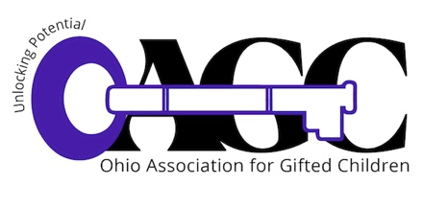

To: **OAGC Region Representatives** and

**Affiliate Groups**

From: OAGC Scholarship Raffle Committee

**Re: Scholarship Raffle, OAGC Conference,**

**October 16-18, 2022**

j0353859

It is time to prepare for the OAGC Scholarship Raffle to be held at the annual conference with proceeds providing support for the OAGC Student Scholarships and OAGC College Scholarships. With your support, the raffle has grown bigger and better each year, and is highly anticipated by many conference attendees. The current economic distress makes the scholarships OAGC provides even more important to students and families in every region across the state.

j0290558

Each OAGC Region and Affiliate Group is asked to donate a “basket” for inclusion in the raffle. These baskets need not be expensive—recent donations included gasoline cards and lottery tickets—and you may solicit donations from individuals, businesses, museums, artists and organizations in your region. Containers may be baskets, tubs, boxes, etc.; whatever will catch the eye of conference participants. Baskets could be centered on a theme such as holidays, hobbies, collectibles, basic food groups (chocolate), an age group, or whatever your ***creativity*** can conjure! **Please remember to wrap the entire basket in clear cellophane, and, please, *no unwrapped food items.***

Please help us ensure that all those who contribute to the basket are acknowledged by completing the Scholarship Raffle Donor list. Return the list to either of the Scholarship Raffle co-chairs via email by **October 10th and attach a copy to the basket. This list is your insurance in case a basket item is lost or broken and is required for tax purposes.**

Tara Toft

Phone: 419.656.6474

Email: [ttoft@scs-k12.net](mailto:ttoft@scs-k12.net)

j0290558Please arrange for the basket to be delivered to the conference headquarters at the Hilton on Sunday afternoon/evening, October 16th, before 6:00 PM.

Questions? Please contact the Chair by phone or email anytime.

Thanks for your help!