OAGC VIRTUAL Family & Community Day  SUNDAY October 15, 2023  2:00 p.m. to 5:00 p.m.  Featuring Presenters:  Anne Flick, Molly Issacs-McLeod, Katrice Quitter, and Lauren Webb,  Anne Flick is a coordinator of gifted services at the Hamilton County ESC.  Molly Issacs-McCleod JD, LL.M., is the president of Gifted Unlimited, LLC., a support and resource group for families of gifted children.  Katrice Quitter began her career as an early childhood educator focused on access and equity of quality early learning experiences for young children, birth to 5 years. In Katrice’s career as an educator, it has always been a focus to provide an optimal learning experience for all students regardless of background or identity. Katrice has taught elementary, worked as an Instructional Coach, Gifted Intervention Specialist, Gifted Coordinator and most recently as an Educational Consultant who designed and facilitated impactful professional learning for educators and administrators.  Lauren Webb directs Lakota’s Gifted Services K-12 and facilitates the gifted professional development for all Lakota teachers. In addition, she helps with the implementation and training for suicide prevention district wide including Hope Squad and Sources of Strength.  Joseph Januzzi, NCSP  School Psychologist Panel  Co-presenters:  Joseph Januzzi, NCSP  School Psychologist  jjanuzzi@scs-k12.net  Sarah Kaya, LSW  School Social Worker  skaya@scs-k12.net  Morgan Dunleavy, MSW, LSW  School Social Worker  mdunleavy@scs-k12.net  For questions of for more information please  contact Sara Watson at  watson.sara@gmail.com or visit www.oagc.com/fallconference.asp |  |  |  | 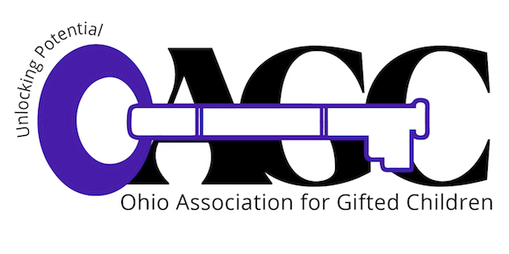REGISTRATION FREE!  2:00 - 2:10 PM - Welcome  2:10 - 3:00 PM - Beyond Legos: Hands-On Activities to Nurture Spatial Reasoning  3:00 - 4:10PM – The Question is the Answer  4:10 - 5:00 PM - Early College: Which is the Right Path for Your Child  “Beyond Legos: Hands-On Activities to Nurture Spatial Reasoning” – Anne Flick and Lauren Webb  Research shows spatial reasoning outranks both verbal and mathematical scores in predicting success in STEM (science, technology, engineering, and math) fields. The visual arts also require spatial skills. Studies show these skills can be learned by anyone, but schools rarely teach them. Come learn how parents can fill the gap with a few tricks and lots of great games to play with their kids.  “The Question is the Answer” – Katrice Quitter  We know the ability to ask and answer good questions is a crucial real-world skill. We also know that people do not apply their critical thinking skills without critical thinking dispositions. Critical thinking dispositions are the habits and mindsets that trigger the use of critical thinking skills across different contexts. Inquisitiveness, truth-seeing, and self-confidence can be developed using great discussion questions. After this workshop parents will walk away with a better understanding of the power of questions, multiple quick question frames to use with their children, and tips for how to harness the power of follow-up questions.  “Early College: Which Path is Right for Your Child” – Molly Issacs-McLeod  In this interactive presentation parents and advocates will learn about avenues for accessing post-secondary level content, considerations in determining what path (dual enrollment, community college, residential programs, etc.) is best suited to their child/student, as well as the potential impact on further post-secondary study.

OAGC Family & Community Day
Registration Form
FREE!!!

Complete and return this registration form to the address below by October 9, 2023 or fill out the google form. After October 9th, registrations will be accepted via email, fax or by google form.

Name:

Street address:

City, State, ZIP:

County: | Phone:
E-mail:

Please return your completed registration form by October 10 to
Parent Day Registration
Ohio Association for Gifted Children
P.O. Box 30801
Gahanna, OH 43230 or
Email: oagcregistrar@gmail.com
Phone: 614.337.0386
Fax: 614.337.9286

Note: If you are already registered for the OAGC conference, your admission to Family and Community Day is included in the fee. Do not complete this form.

For questions or for more information, contact Sara Watson at watson.sara@gmail.com

Ohio Association for Gifted Children is a 501(c)(3) organization
P.O. Box 30801; Gahanna, OH 43230

