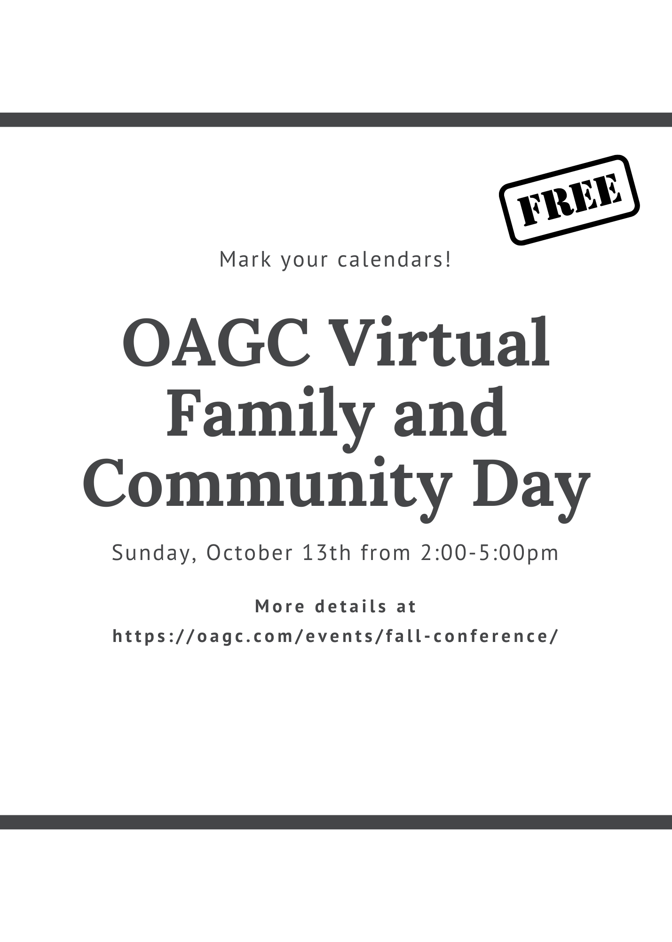
OAGC Family & Community Day
Registration Form
FREE!!!

Complete and return this registration form to the address below by October 7 2024 or fill out the google form. After October 7th, registrations will be accepted via email, fax or by google form.

Name:

Street address:

City, State, ZIP:

County: | Phone:
E-mail:

Please return your completed registration form by October 7 to
Parent Day Registration
Ohio Association for Gifted Children
P.O. Box 30801
Gahanna, OH 43230 or
Email: oagcregistrar@gmail.com
Phone: 614.337.0386
Fax: 614.337.9286

Note: If you are already registered for the OAGC conference, your admission to Family and Community Day is included in the fee. Do not complete this form.

For questions or for more information, contact Abbie Sigmon at oagcgifted@gmail.com

Ohio Association for Gifted Children is a 501(c)(3) organization
P.O. Box 30801; Gahanna, OH 43230

